National University of Computer and Emerging Sciences



Lab 02

COAL LAB

|  |  |
| --- | --- |
| Name | Muhammad Zain |
| Roll No. | 19F-0228 |
| Lab Instructors | Mr Abuzar Ghfari |
| Semester | Fall 2020 |

Problem 1:

# Solution 1.1

**Address Content Index**

00 78 dvar

01 56 dvar+4

02 34 dvar+8

03 12 dvar+16

# Solution 1.2

The Value of num 1 is **3007H**

# Solution 1.3

In this code **Wvar** is stored in **dw** whose data type contain 2 bytes hence **ptr** pointer which means we are breaking 2 bytes with 1 each .

# Solution 1.4

yes, there is an error in it because y is constant so that’s why we are unable to initialize again.

# Solution 1.5

Offset address **Wvar** is 1

Offset address **count** is 8

Snap

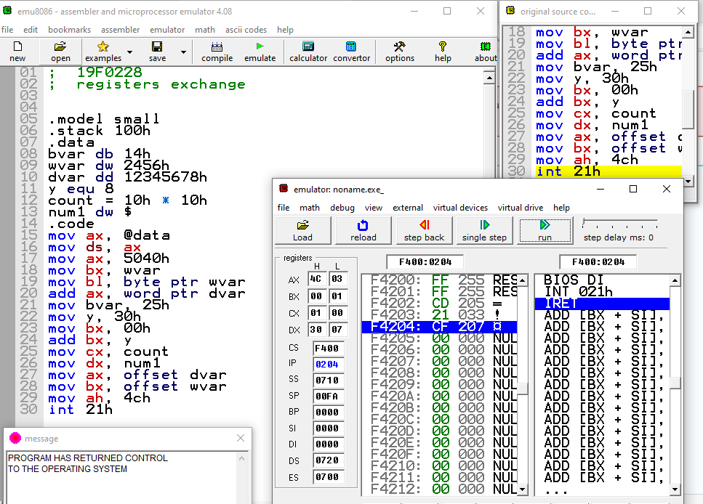

Problem 2:

# Solution 2.1

After the execution of **mov al barr+4**

**Al=65**

# Solution 2.2

After the execution of **mov bx warr+1**

**Bx=6924**

# Solution 2.3

**Array num2** 00h,00h,019h

# Snap shot

Problem 3:

# Source Code

; 19F0228

; Fabonanci Series

.model small

.stack 100h

.data

arr DW 6 DUP(?)

.code

mov ax, @data

mov ds, ax

mov AX,1

mov BX,2

add AX,BX

add BX,AX

add AX,BX

add BX,AX

mov ah, 4ch

int 21h

# Snip:

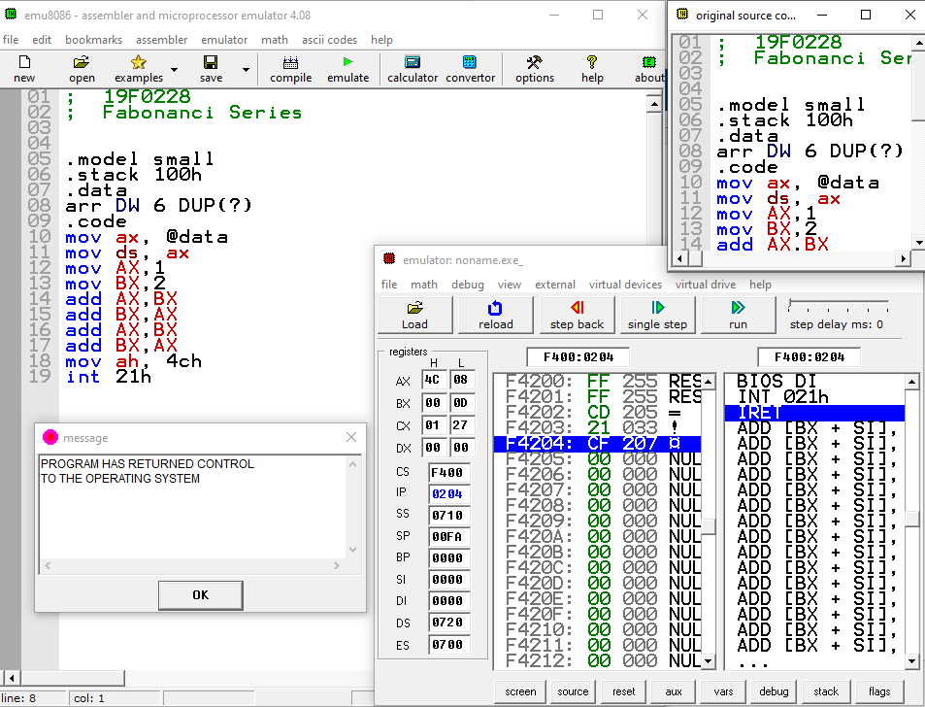

Problem 4:

# Source Code

; 19F0228

; registers exchange

.model small

.stack 100h

.data

Uarr DW 1000h, 2000h, 3000h, 4000h

Sarr DW -1, -2, -3, -4

.code

mov ax, @data

mov ds, ax

mov AX,Uarr

mov BX,Uarr+2

mov CX,Uarr+4

mov DX,Uarr+6

mov AX,Sarr

mov BX,Sarr+2

mov CX,Sarr+4

mov DX,Sarr+6

mov ah, 4ch

int 21h

# Snip

